**Integration of GPS hat to Raspberry Pi 3**

**Table of Content**

Page

Configuration of Raspberry Pi 3…………………………………………………………...3

Installing pynmea2……………………………………………………………………………..5

Installing NTP server…………………………………………………………………………..6

Setting up the static IP address of the raspberry Pi………………………………..9

Troubleshooting………………………………………………………………………………...10

**Configuration of Raspberry Pi 3**

**\*\*Note That you are not supposed to attach the GPS hat (board) to the Raspberry Pi 3 yet (Don’t be so gan cheong)**

Update Raspberry Pi 3 using the command

sudo apt-get update && sudo apt-get dist-upgrade –y

Updating and upgrading will take approximately 20-10 minutes so just sit back relax and chill.

After updating Rpi 3, use the command

sudo raspi-config -> Advanced options -> Serial. Make sure that the serial is made accessible (set it to Yes).

Next (Only for raspberry Pi 3)

type sudo nano /boot/config.txt

Make sure that the line is “enable_uart=1” (Note it has to be 1 not 0). Go to the last line of the text and type “dtoverlay=pi3-miniuart-bt” and “force_turbo=1”.

Use the command sudo nano /boot/cmdline.txt Change the line to

dwc_otg.lpm_enable=0 root=/devmmcblk0p**7**rootftype=ext4 elevator=deadline fsck repair=yes rootwait.

(Basically just delete any console references AND ONE IMPORTANT POINT, the 7 that I bold and coloured in red, the 7 is just a sample for the raspberry pi 3 it can be other numbers i.e 2. DO NOT CHANGE THE NUMBER!! If not the raspberry pi will hang when rebooting later.)

sudo nano /lib/system/system/hciuart.service

Change the line After=dev-serial1.device to After=dev-ttys0.device

Change the line ExecStart=/usr/bin/hciattach/dev/serial1 bcm43xx 921600 noflow – to

ExecStart=/usr/lib/hciattach/dev/ttys0 bcm43xx 460800 noflow –

Power off the Pi using sudo shutdown –h now

Now you can attach the GPS hat together with an aerial to the raspberry Pi 3.

Start up the raspberry Pi 3. Then you wait again for a while, drink some coffee or disturb your colleagues if they are around.

After a while, the timepulse on the GPS hat will start blinking. (Make sure the green LED is blinking and not any other colour. Actually you can’t get any other colour except green haha unless you change it physically). Ok back to business, after 15-30 minutes, Once the LED starts blinking,

Type stty –F /dev/ttyAMA0 raw 9600 cs8 clocal –cstopb then cat /dev/ttyAMA0

Something will be generated almost immediately. If there is nothing, that means you are screwed ☹.

But fret not, there is still a way, head on over to the troubleshooting section below.

Continuing with the process, CTRL+C to stop the data from running and find the line starting with $GNGGA. If there are a lot of numbers, it means the GPS is tracking already. If there are lot of commas, its fine, you just have to either wait a while longer or you have to move the GPS nearer to line of sight to the open sky. (I placed mine beside the window)

Once done, install serial and pynmea2. Serial is already pre-installed in the Pi so we can skip this yeaaaaa!!!!

**Installing pynmea2**

Sudo apt-get install python-pip

Sudo pip install pynmea2

Git clone git://github.com/modmypi/GPS

Cd GPS

Sudo python gps.py

After running the last command, another list of data will be generated, a new list of data where you can finally see and know what the numbers are for. Just check that the timestamp is correct. (The time generated will be for the universal time, just make sure that the raspberry pi clock is set to Singapore, and go to troubleshooting to see how to do it).

If it is running smoothly with no sudden interruption, then you are good to go. Then do some testing, unplug the Ethernet cable or disable the wifi and run the command again to see if the gps readings can still be generated with no internet access.

**Installing NTP server**

**Prerequisite Settings**

sudo raspi-configAdvanced Options -> Serial -> Would you like a login shell to be accessible over serial? -> Yes  
Quit but no need to reboot at this point.

sudo nano /boot/config.txt  
Add at the bottom :

# Allow the normal UART pins to work  
dtoverlay=pi3-miniuart-bt  
dtoverlay=pps-gpio,gpiopin=18  
Save and Quit Nano.

sudo apt-get updatesudo apt-get dist-upgrade

sudo systemctl disable hciuartsudo systemctl mask serial-getty@ttyAMA0.service

sudo apt-get install pps-toolssudo apt-get install libcap-devsudo reboot

dmesg | grep pps

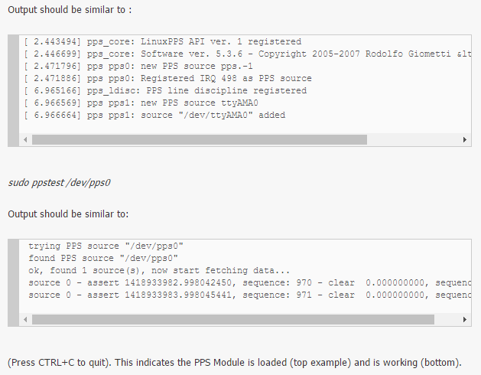

wget http://www.eecis.udel.edu/~ntp/ntp_spool/ntp4/ntp-4.2/ntp-4.2.8p7.tar.gz  
tar zxvf ntp-4.2.8p7.tar.gz  
cd ntp-4.2.8p7  
./configure  –enable-linuxcaps  
make -j4  
sudo make install  
sudo service ntp stop  
sudo cp /usr/local/bin/ntp* /usr/bin/ && sudo cp /usr/local/sbin/ntp* /usr/sbin/  
sudo nano /etc/ntp.conf

Add  
server 127.127.22.0 minpoll 4 maxpoll 4  
fudge 127.127.22.0  flag3 1  refid PPS

Amend

server 0.debian.pool.ntp.org iburst prefer

sudo nano /etc/init.d/ntpFind the line NTPD_OPTS=”$NTPD_OPTS -u $UGID”Amend it to say NTPD_OPTS=”$NTPD_OPTS”

sudo systemctl daemon-reload

sudo service ntp restart

After a few minutes run

ntpq –p

If you get oPPS(0) this indicates source selected, Pulse Per Second (PPS) used and everything is working. If not go to the troubleshooting section.

Once everything is ready, run to check that the timestamp can be generated. Then it is time to finish up the configuration.

**Setting up the static IP address of the raspberry Pi**

Sudo nano /boot/cmdline.txt

Just add pi=192.168.0.1 at the end of the line and you are done.

**Do note that the IP address can differ so have to ask your boss what static IP your boss wants.

After everything, reboot the raspberry Pi. Type hostname –I check that the static IP is the one that you set. If you have 2 IP address, don’t worry, it just means that you still have internet connection, unplug the Ethernet cable or disable the wifi and the second IP address will be gone.

Finally, run the program to check the GPS timestamp WITHOUT internet.

**Troubleshooting**

Welcome to this section, i have majority of the solutions that you need here. If you find more, just add it in don’t be selfish.

1. Raspberry Pi 3 hangs after the reconfiguration. This is the most irritating part. There is only one way which is to reflash the sd card. Sorry but there is no other way.
2. After running cat /dev/ttyAMA0, nothing is generated, the program just hangs there. It means the AMA0 port is not ready to be used yet.

Go to ls –l /dev. There will be a list of ports you can use. Check that You have this : 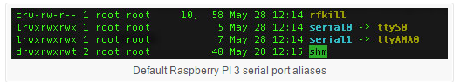

If you don’t, redo the steps from configurating the raspberry PI to just before you attach the GPS hat to it.

1. There should be not much of a problem for the NTP server installation. After running ntpq –p, if you don see the PPS settings, do this:

rm /etc/dhcp/dhclient-exit-hooks.d/ntprm /var/lib/ntp/ntp.conf.dhcp

1. Useful links: (I got every information from here)

Installing GPS Hat on Raspberry Pi

<https://www.modmypi.com/blog/raspberry-pi-gps-hat-and-python>

Installing NTP Stratum 1 Server on Raspberry Pi

<http://ava.upuaut.net/?p=726>

Checking of serial ports

<http://spellfoundry.com/2016/05/29/configuring-gpio-serial-port-raspbian-jessie-including-pi-3/>

Disabling Wifi and Bluetooth

<http://pingtool.org/raspberry-pi-3-disable-bluetooth-wifi/>